To: | Scrutiny Committee
Date: | Date of the meeting 5 April 2018
Report of: | Policy and Partnerships Team Manager
Title of Report: | Health Inequalities – 12 Month Progress Update

Summary and recommendations
Purpose of report: |  | The Scrutiny Committee made a series of recommendations to the City Executive Board in March 2017 concerning health inequalities in the City. This report provides an update on progress made against the recommendations.
Key decision: |  | No
Executive Board Member: |  | Councillor Tidball, Board Member for Young People, Schools and Public Health
Recommendation(s):That the Scrutiny Committee resolves to:
1. | Note and comment on the report
2. | Provide any recommendations as necessary.

Appendices
Appendix 1 | Actions taken against the Health Inequalities Commission Recommendations
Appendix 2 | Health inequalities data produced by the CCG
Appendix 3 | 12 Month Progress Update on Scrutiny Committee Recommendations

Background
The Oxfordshire Health Inequalities Commission report was presented to the Health and Wellbeing Board in November 2016. The Commission gave 60 recommendations for a wide variety of groups and organisations and it was intended that they would be taken forward by a range of bodies e.g. voluntary sector organisations.
The recommendations are set out in various groups in the report as illustrated in the figure overleaf:
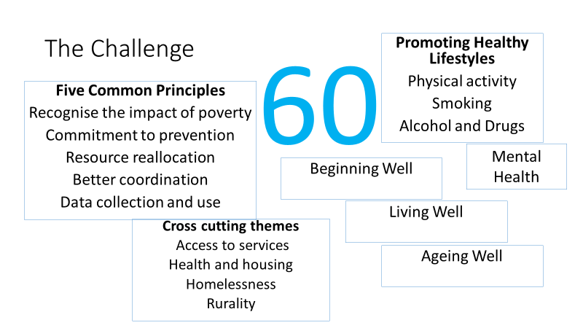

Health Inequalities Commission (HIC) Implementation Group
An Implementation Group has been convened under the leadership of the CCG. This group includes Oxford City Council’s Policy and Partnership Team and Councillor Marie Tidball. The HIC Implementation Group has reviewed all the recommendations set out by the Commission and compiled a comprehensive overview of relevant work currently underway or in the planning stages. This can be viewed in Appendix 1. The group now uses a basket of health inequalities data produced by the CCG to guide the priorities. This can be viewed in Appendix 2

- Priority business for the Implementation Group in 2017-18. This group of recommendations needs the coordination and input of the Implementation Group to be taken forward. These are set out in five areas of work which will deliver 26 of the recommendations. The 5 work areas are:
  - Basket of Inequalities Indicators
  - Innovation Fund
  - Income Maximisation
  - Social Prescribing
  - Promoting Physical Activity as part of improving prevention of ill health.

- Recommendations being taken forward by specific groups / organisations in 2017-18. Good progress is being made on work to implement 15 recommendations and some have been completed.

- Recommendations to be considered for future implementation. A further 19 recommendations are under consideration and not yet being fully implemented.

Challenges
The partnership consensus was that all recommendations would be implemented by including them within existing work programmes. This would include:

Adapting and developing existing systems and processes
Partners were reluctant to set up new structures or write separate action plans but wanted to include action in their mainstream plans. The report highlights one way to do this is to take the Health in All Policies approach.
This year has evidenced that the work needed by Oxford City Council to realise some of our ambitions around the implementation of the recommendations has required further resource capacity both in terms of funding and staff time. Moving forward this needs some further exploration.
A 12 month progress update on the 10 recommendations made by the Scrutiny Committee in March 2017 can be found in Appendix 3.

Report author | Daniella Granito
Job title | Policy and Partnership Team Manager
Service area or department | Chief Executive Directorate
Telephone | 07483 010758
e-mail | DGranito@oxford.gov.uk

Background Papers: None

